Problem 1

Part 1

1. length(x) = 3
2. sum(x) = 12
3. x+y = 5, 2, 5
4. x\*y = 4, 0, -6
5. x-2 = 2, 0, 4
6. x^2 = 16, 4, 36

The first two operations show information about the list of numbers x, length(x) giving the number of values in the list and sum(x) adding each of the three values together. The following operations affect each individual number in the list, such as x^2 squaring each number in the list x.

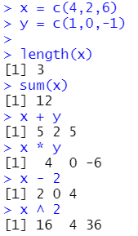

Part 2

Sequence in R shows the numbers between two points, such as 7:11 showing all integers from 7 to 11. The following operation seq(2,9) is another way to write 2:9. The next operation includes *by=2*, which only counts by 2 between the selected numbers 4 and 10. The last operation repeats the *NA* ten times.

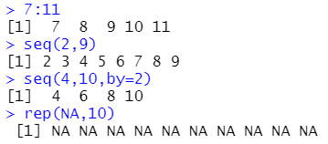

Part 3

1. x[2] = 9
2. x[2:4] = 9, 2, 3
3. x[c(2,3,5:7)] = 9, 2, 4, 6, 7
4. x[-(10:12)] = 5, 9, 2, 3, 4, 6, 7, 0, 8

The first operation shows the second number in the list x. The second operation shows the second, third, and fourth numbers in the list x. The third operation shows a list of numbers that the user wants to show, which includes the numbers at the 2nd, 3rd, 5th, 6th, and 7th positions in the list. The last operation shows the user all numbers except for the numbers in the 10th, 11th, and 12th positions.

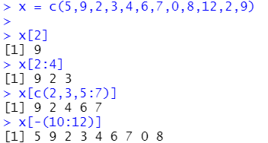

Problem 2

1. 2 variables with 29 observations



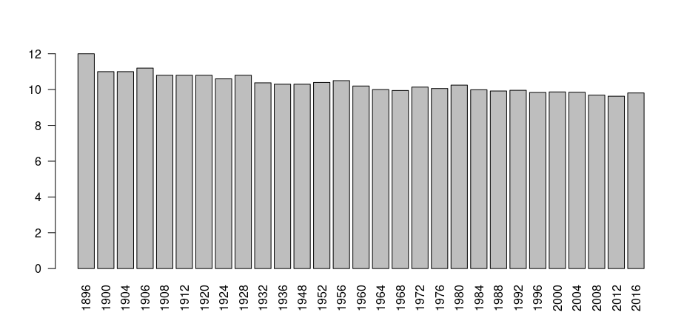

1. Graph 2 makes it look like there is quite a big difference in times when it is really only 3 seconds.This is because graph 2 starts at a higher value which lets you see the difference between the years better.

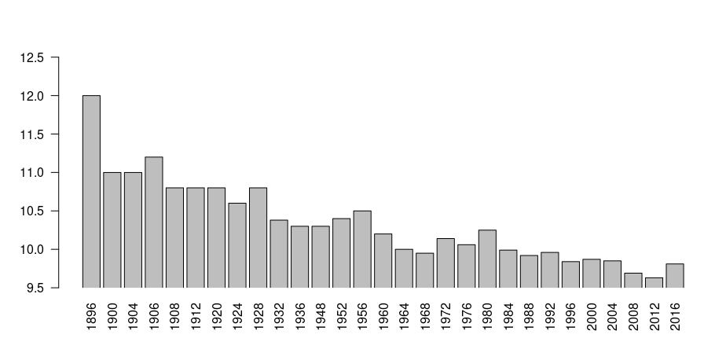

Problem 3

1. 11 variables and 74 observations



1. 52 domestic, 22 foreign

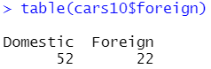

1. The 26th car has the lowest mpg at 12 mpg and is a Lincoln Continental

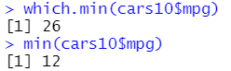

1. The 13th car is the most expensive at $15906 and is a Cadillac Seville

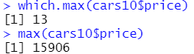

1. The histogram takes a right-skewed shape, meaning there is a higher frequency on the lower x-values.

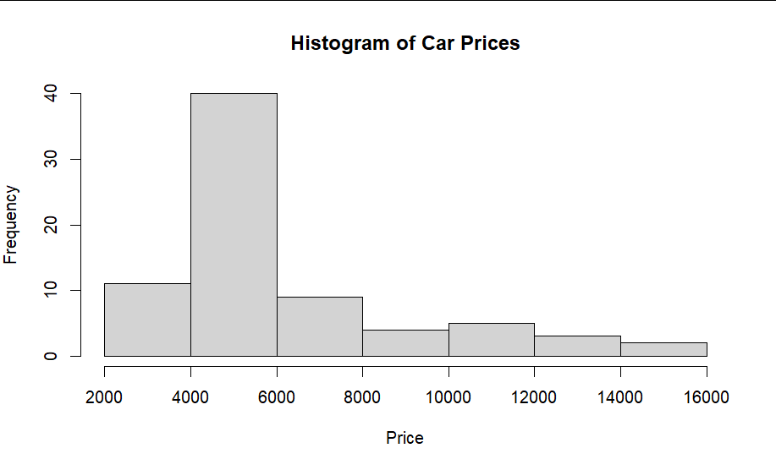

1. 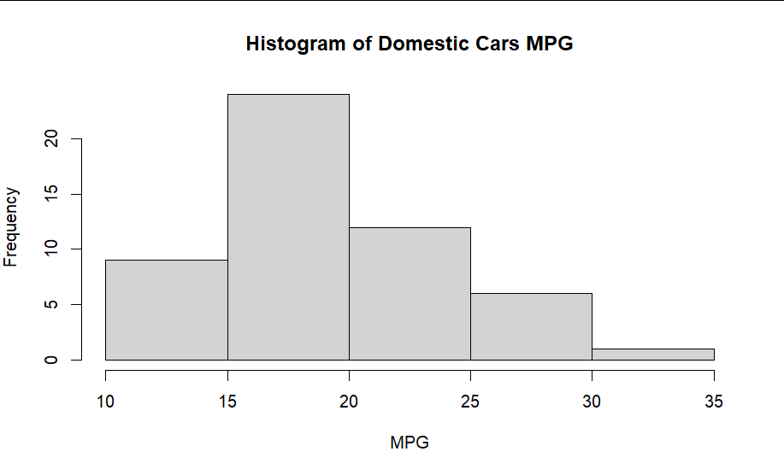

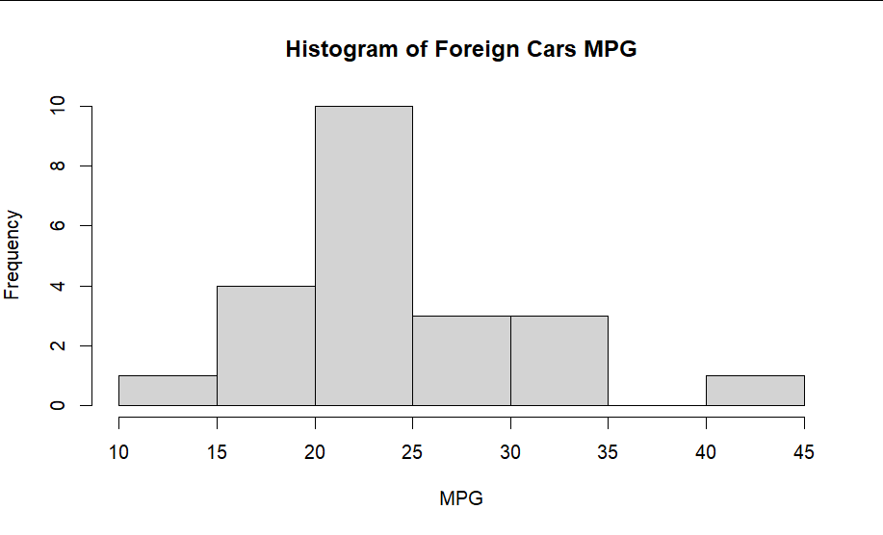

The two histograms share similar shapes, between being right-skewed and being symmetrical. The second histogram, *Histogram of Foreign Cars MPG*, has a wider range of x-values and has a shorter range of y-values for the frequency. This can indicate that the foreign cars vary more than the domestic cars in MPG.

1. 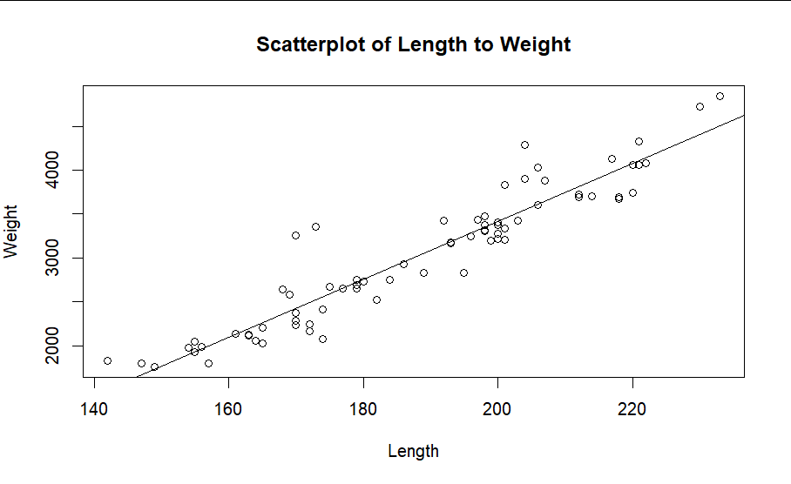

There does appear to be an association between the length of the car and the weight of the car. The longer the car, the more the car weighs, as observed from the line in the scatterplot.

Problem 4

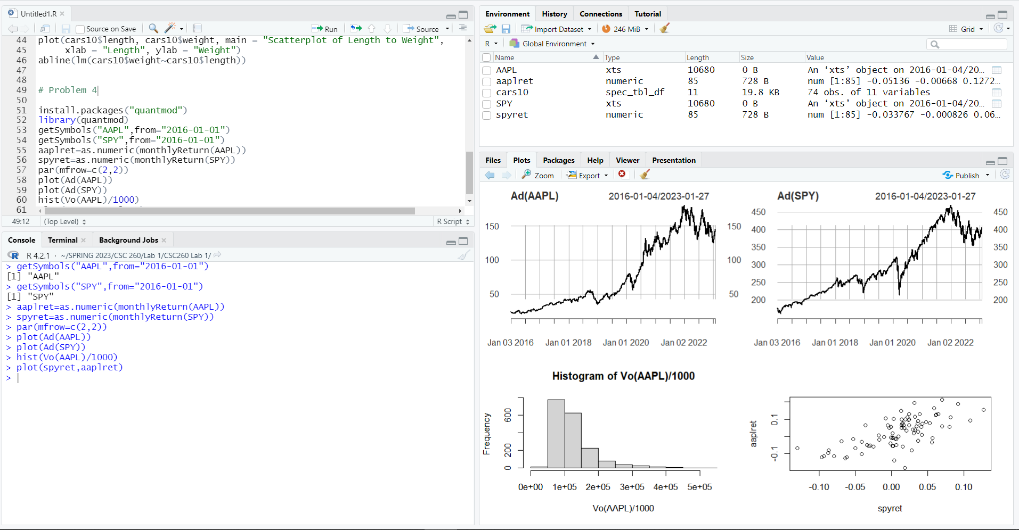

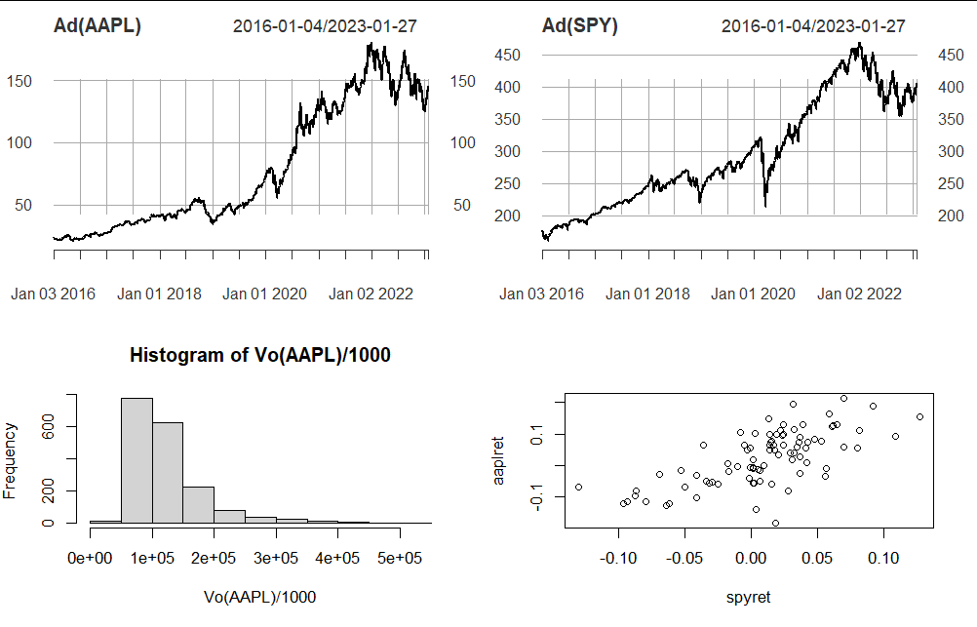

Running the code results in this set of graphs. This shows graphs of monthly financial data from January 1st, 2016, for AAPL (Apple) and SPY (S&P 500). The bottom left graph shows a histogram of frequencies of price points for AAPL, which can indicate an average range when the frequencies are higher. The last graph is a scatter plot to compare both AAPL’s and SPY’s influence on each other, with a strong enough relationship can show that when SPY is up in price, AAPL is up in price.